Final Lab Project Report

Adnan Athar- 20240005105
Ibrahim Alamgir- 20230003912

Problem Statement
Retail stores and small businesses often struggle to manage inventory manually, leading to issues such as inaccurate stock records, outdated pricing, unmanaged perishable items, and errors caused by manual data entry. These challenges make it difficult for store managers to efficiently monitor product availability and maintain reliable inventory data.
To address these issues, there is a need for a structured, user-friendly software solution that automates inventory tasks and reduces human error. This project aims to develop a console-based Inventory Management System in Java that allows store managers to add, update, view, delete, and search products, including perishable items with expiry dates. The system will follow Object-Oriented Programming (OOP) principles and include robust exception handling to ensure smooth and error-free operation.

Objectives
The main objectives of this project are:
- To develop a GUI-based Inventory Management System that helps store managers efficiently manage product information.
- To automate common inventory operations, including adding, viewing, updating, deleting, and searching products.
- To apply Object-Oriented Programming principles such as encapsulation, inheritance, and method overriding in the system design.
- To incorporate exception handling to ensure the program can manage invalid inputs without crashing.
- To provide support for perishable products, including tracking of expiry dates using inheritance.
- To create an interactive interface that ensures ease of navigation and user-friendly interaction.

Scope
The scope of the Inventory Management System includes:
In-Scope
- Managing product data: ID, name, price, quantity.
- Managing perishable products with expiry dates.
- Menu-driven user interactions.
- Updating existing product details.
- Deleting discontinued products.
- Searching products using Product ID.
- Error handling for invalid operations.
- Storing products in a fixed-size array structure.
Out-of-Scope
- Graphical User Interface (GUI)
- File handling

Functional Requirements
The system must support the following functionalities:
FR1: Add New Product
The system shall allow the user to add:
- General products
- Perishable products with expiry date
FR2: View All Products
The system shall display:
- Product ID
- Name
- Price
- Quantity
- Expiry date (if applicable)
FR3: Update Product Details
The user shall be able to modify:
- Product price
- Product quantity
FR4: Delete Product
The system shall allow deleting a product using its Product ID.
FR5: Search Product
The system shall allow searching products using their unique Product ID.
FR6: Exception Handling
The system shall handle:
- Invalid inputs
- Duplicate IDs
- Out-of-range values
without crashing the application.

Non-Functional Requirements
NFR1: Usability
The interface must be simple and intuitive for console use.
NFR2: Reliability
The system should handle errors gracefully using exceptions.
NFR3: Maintainability
The code should follow OOP principles, making it easy to extend or modify.
NFR4: Performance
Operations such as add, search, and update must execute efficiently using a fixed-size array.
NFR5: Portability
The application should run on any system with Java installed.

Source Code
All shared via zip file.

Output (Main deliverable)

  - Below is the main Graphical-User-Interface page
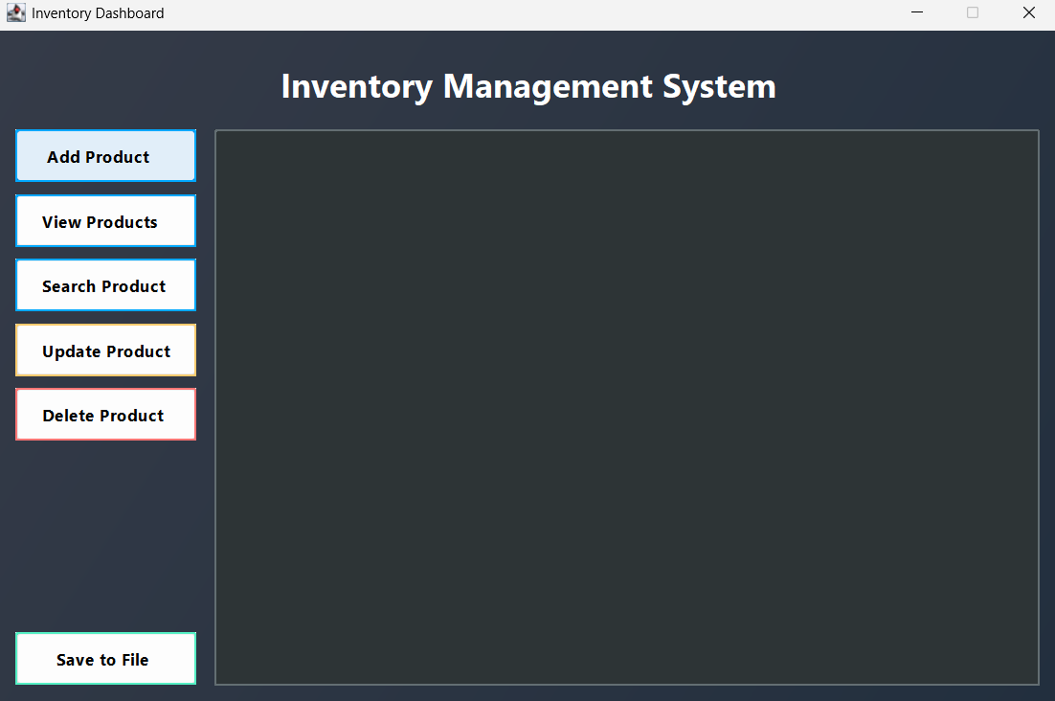

  - Below is the message shown after adding a product
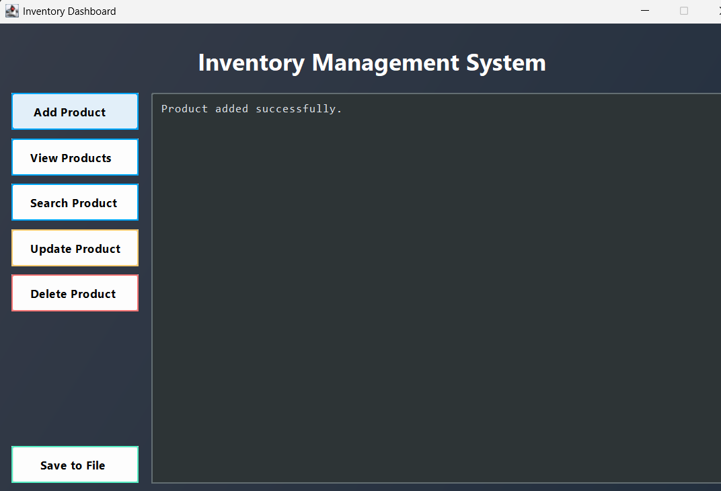

  - Our program also checks for perishables and expiry date

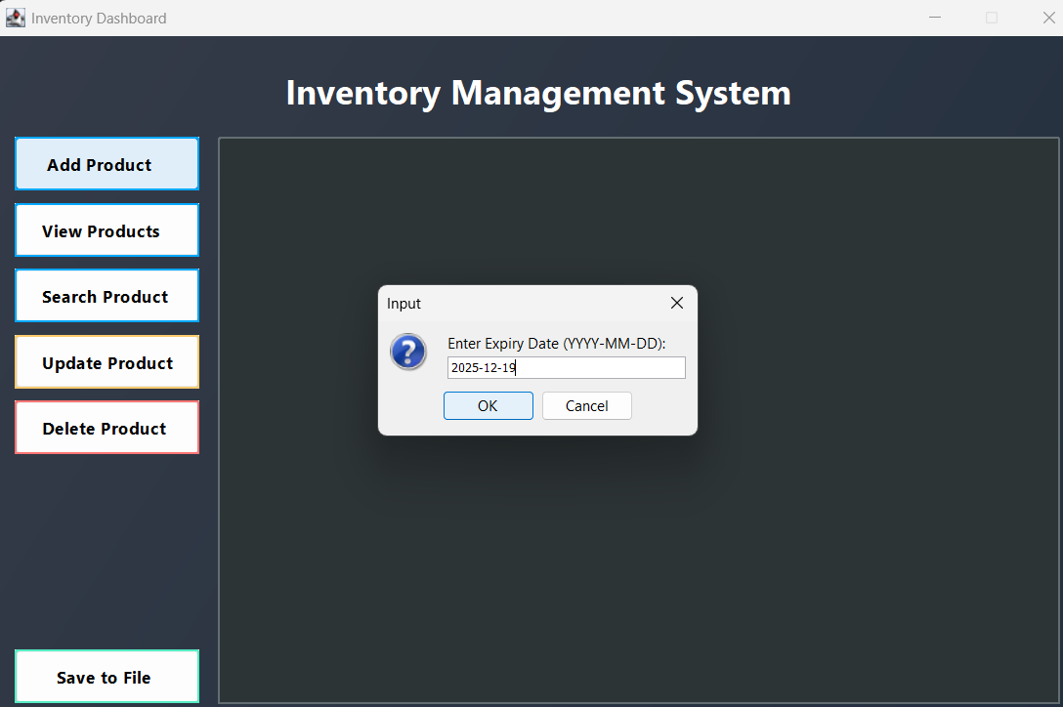

- The program displays all products seamlessly on the interface

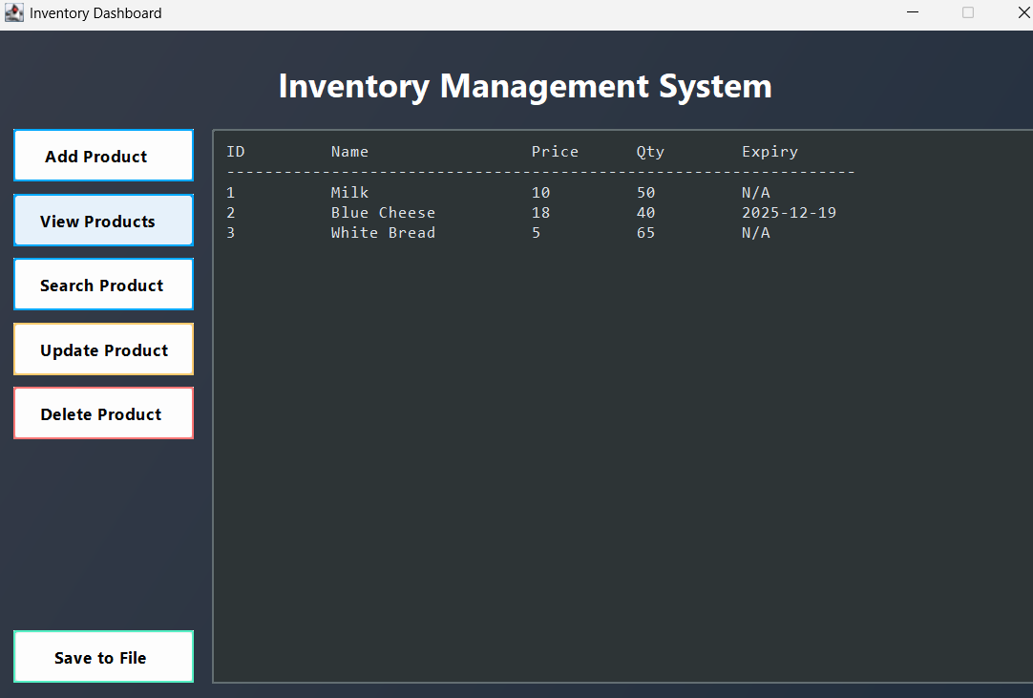

- The program searches for products through ID

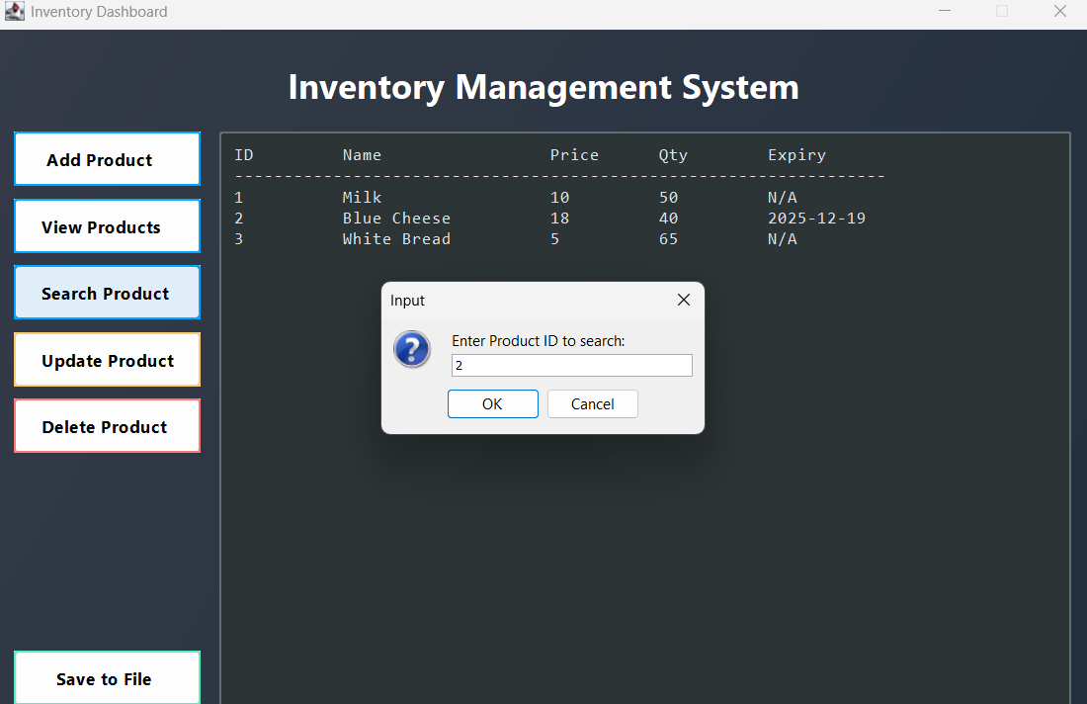

After we click ok, below is the output

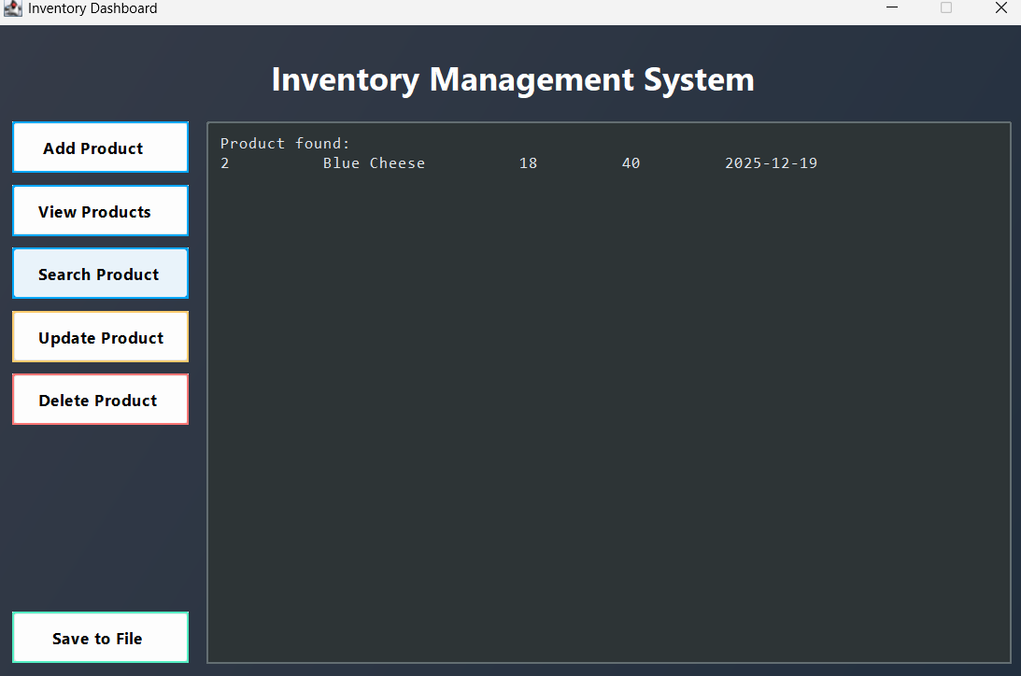

- The update product option gives us a drop down list and gives different options to update

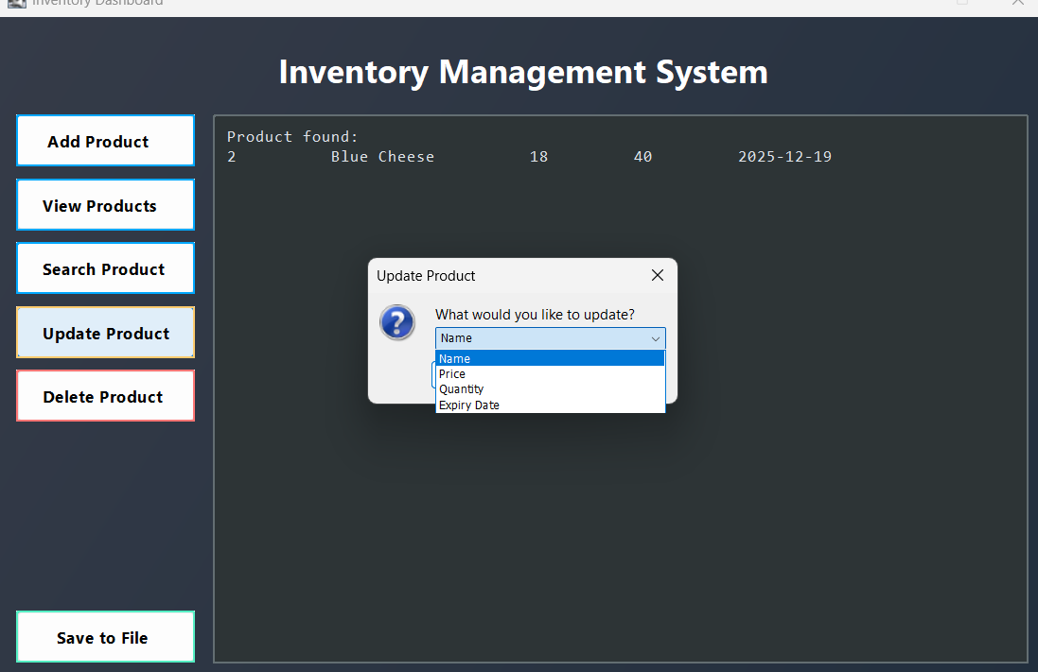
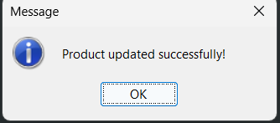
Below is the output after updating the name with Product ID 2 from Blue cheese to goat cheese
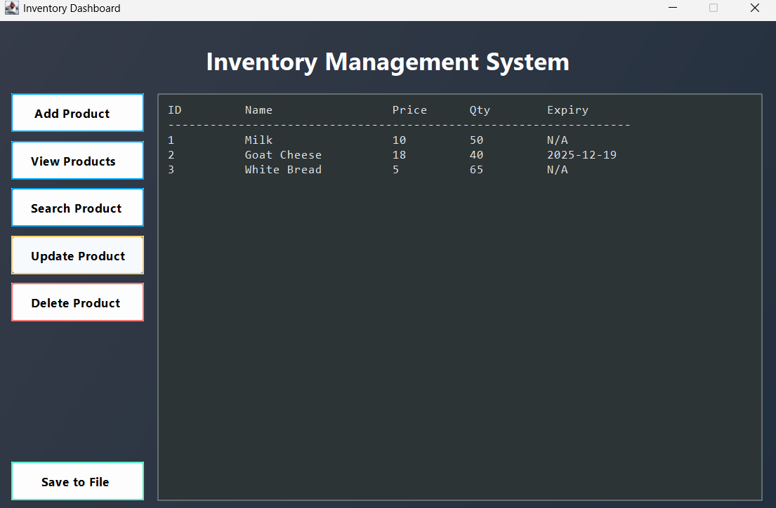

- The delete function takes a product ID and respectively removes it from the list
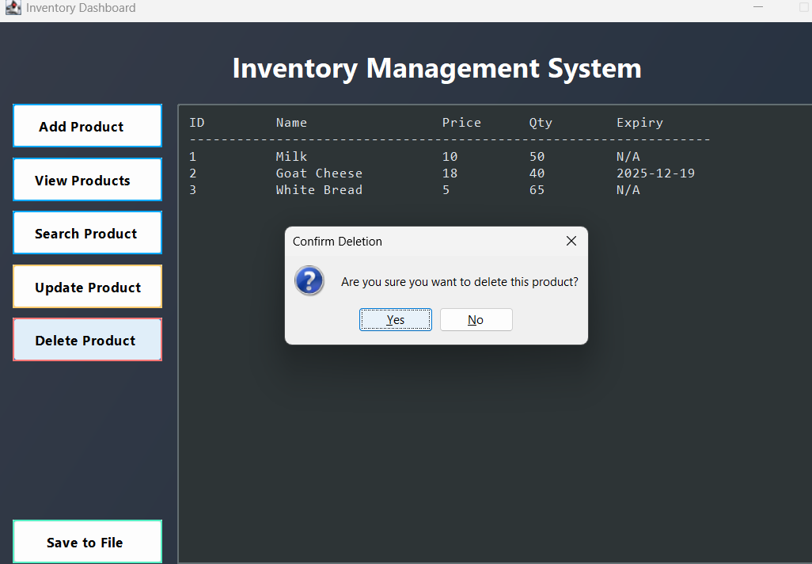

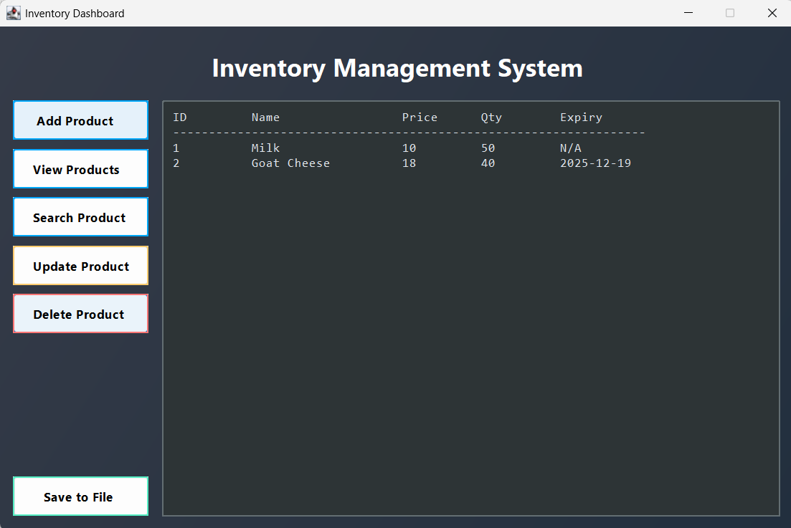

- The program also has a saving to file function which ensures that all the data is stored and not lost each time we run the program

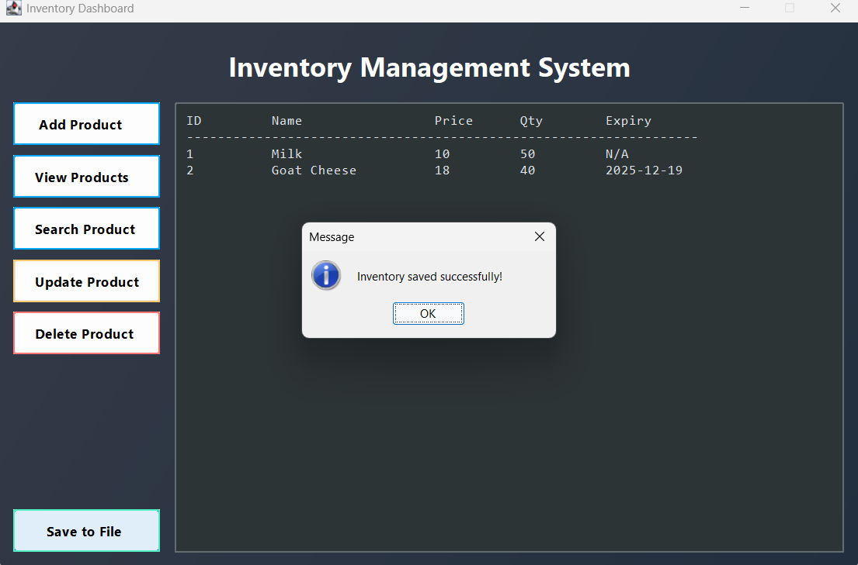
All the data is saved to inventory_data.txt file
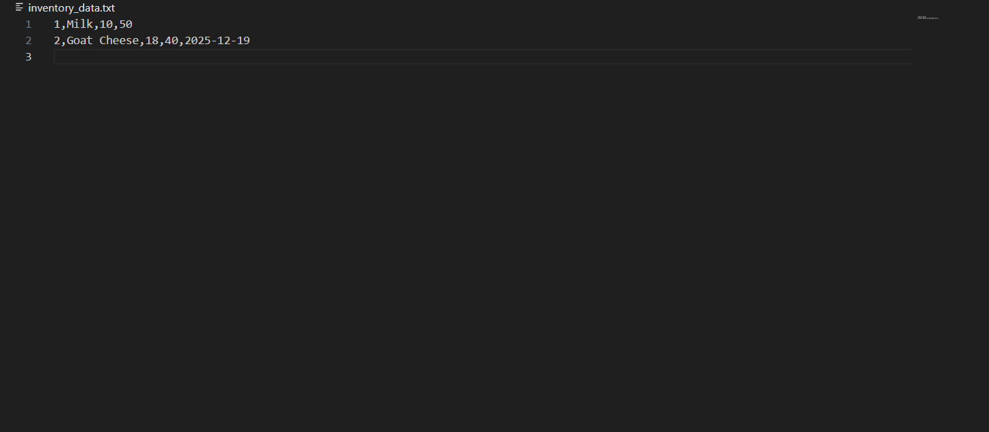

Edge-cases and Exception-Handling

1. Input Validation (InvalidInputException)
Purpose: Prevents adding invalid data like negative price or zero ID.
Where: Inside both addProduct() methods.
Checks include:
if (id <= 0) throw new InvalidInputException("Product ID must be positive.");
if (price < 0) throw new InvalidInputException("Price cannot be negative.");
if (quantity < 0) throw new InvalidInputException("Quantity cannot be negative.");
Effect: Ensures only valid, positive values are accepted before creating a Product object.

2. Duplicate Product Prevention (DuplicateProductException)
Purpose: Avoids adding two products with the same ID.
Where: Inside both addProduct() methods
for (int i = 0; i < count; i++) {
if (products[i].getProductId() == id)
throw new DuplicateProductException("Product ID already exists.");
}
Effect: Ensures each product ID is unique in the system.
3. Product Not Found (ProductNotFoundException)
Purpose: Handles attempts to update, delete, or search for non-existent products.
Where:
- In findProductById()
- Used by: updateProductName, updateProductPrice, updateProductQuantity, updateProductExpiry, deleteProductById, searchProductById
private Product findProductById(int id) throws ProductNotFoundException {
for (int i = 0; i < count; i++) {
if (products[i].getProductId() == id) return products[i];
}
throw new ProductNotFoundException("Product with ID " + id + " not found.");
}
Effect: Gracefully informs the user that an operation failed because the product doesn’t exist.
4. File Input/Output Errors
Purpose: Prevents the program from crashing when saving or loading data.
Where:
- In saveToFile() and loadFromFile()
catch (IOException e) {
System.out.println("Error saving to file: " + e.getMessage());
}

Effect: Handles unexpected disk or file access issues without breaking the program.

GUI-Level Exception Handling
Purpose: Converts Java exceptions into user-friendly popup messages via (JOptionPane).
Where: In InventoryGUI.java
Effect: Prevents crashes from invalid input or backend errors and provides clean feedback to users.

